00a- Meeting Minutes - Supervisor

Part1: Meeting information

Group Number | 12
Project Phase: | Project Kickoff
Date/Time: | May 1, 9:00am
Type: | Supervisor
Minute Taker: | Cole
Attendees: | Hoda, Cole, Kyle, Jonah, Nick, Abdullah
Regrets: | None

Part 2 Notes:

Discussed dividing roles in the group, improving detail in trello board.

more work needs to be done on:
: trello (epic, story, hours)

: SOW (who did which section)

: detailed job assignments and respective roles for each members

: who is leader

Monday:
: better trello board

: short 5-10 min presentation (for overview of the project: problem, solution, schedule from SOW)

Part 3: Action Items
Owner | Task ID (existing or NEW) | Change / New Task Summary | Risk/Issue? (Y/N)  Risk ID | Status  (Open / Closed) | Screenshot of Trello Card(s)
Jonah | #11 | Configure trello board for different task types, story points, time, etc | N | Open | 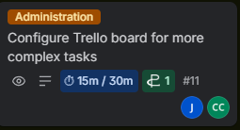
Jonah, Cole, Kyle, Abdullah | #6 | Prepare 10-15m presentation for Monday | N | Open | 